**I. Biology lab activity – comparing human and frog responses to cold**

“Metabolism” refers to the set of chemical processes needed to sustain life, and “metabolic rate” measures how fast an organism burns up chemical energy to power its metabolism. The whole-body metabolic rate is a key characteristic of an organism because it affects all biological rates including growth, development, aging, and muscle performance. Body temperature has important effects on metabolic rate, but different organisms have evolved different responses to changes in external temperature. **In this lab, you will compare and contrast human versus frog metabolic responses to cold temperatures.**

**“Warm-blooded” versus “Cold-blooded”:**

Like most mammals, humans maintain a constant body temperature all the time regardless of external temperature. When we are exposed to very cold or very warm temperatures, our bodies respond in a process called “**thermal homeostasis**” (homeo = “same” or “constant”), which means working to maintain a constant temperature. If our body temperature gets too warm, we produce sweat, which cools our skin and sheds heat into the environment as it evaporates. If our body temperature gets too cool, we burn chemical energy to produce heat by rapidly contracting muscles (“shivering”) and increasing our basal metabolic rate. This ability to produce internal heat is what makes us “**endothermic**” (endo = “internal” and thermic = “related to heat”).

In contrast to mammals, many other animals like insects, lizards, and frogs are “**ectothermic**” (ecto = “external” and thermic = “related to heat”), meaning they allow their body temperatures to match the environmental temperature. They are also sometimes called “cold-blooded”, because their body temperatures tend to be cooler than “warm-blooded” animals like humans. In Michigan, some frog species even allow their bodies to freeze solid during the winter!

**Metabolic Proxies:**

The most direct way to determine an animal’s metabolic rate is to measure how quickly its body uses up oxygen or produces carbon dioxide. However, it is often simpler to measure a “metabolic proxy” like breathing rate or heart rate, which strongly correlates with the animal’s whole-body metabolic rate. In this lab, we will use breathing rate as a proxy for frog metabolic rate, and heart rate as a proxy for human metabolic rate.

**Make some predictions!**

* Based on what you know about frogs, do you think a frog’s breath rate will **increase**, **decrease**, or stay **constant** when the frog is exposed to a cool temperature, compared to a warm temperature?
* Based on what you know about thermal homeostasis, do you think a person’s body temperature will **increase**, **decrease**, or stay **constant** when a body part is exposed to cold water? Why?
* Based on what you know about thermodynamics and human metabolism, do you think a person’s heart rate will **increase**, **decrease**, or stay **constant** when a body part is exposed to cold water? Why?

**Experiment B1. Temperature dependence of frog metabolism (breath rate)**

In this experiment, you will measure how temperature affects a frog’s **breath rate**, which we will use as a proxy for whole-body metabolic rate. Frogs use a unique breathing mechanism called a “buccal pump”, in which they literally “swallow” air into their lungs using their mouth muscles. You will count the number of “breaths” per minute as a proxy for each frog’s metabolic rate.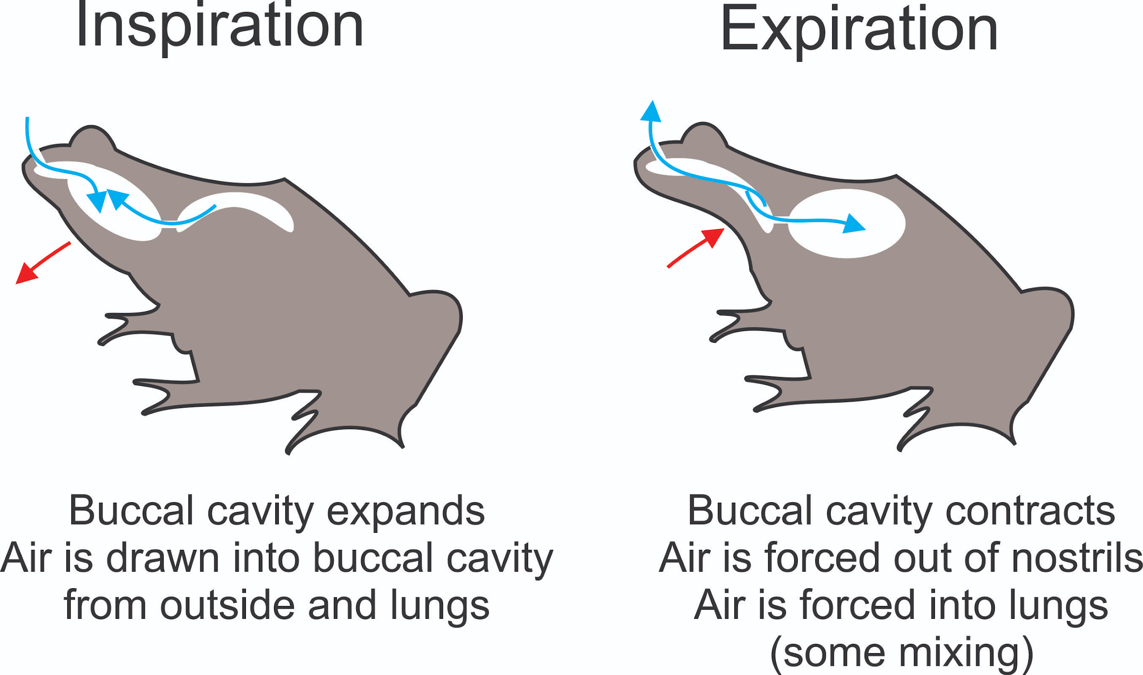

**Procedure B1:**

1. Observe frog respiration in groups of 2-3 students. One student will count respiratory movements, and the other student(s) will keep track of time and record data.
2. Each frog is set to a different body temperature. For each frog, count the number of “breaths” (buccal pumps) taken by frogs in 10 seconds. Record each frog’s identification code, temperature, and number of breaths per 10 seconds in your data table.

**Data Table (try to collect data on all available frogs/toads):**

|  |  |  |  |  |  |  |
| --- | --- | --- | --- | --- | --- | --- |
| Frog ID | Temperature (°C) | Breaths in 10 seconds |  | Frog ID | Temperature (°C) | Breaths in 10 seconds |
|  |  |  |  |  |  |  |
|  |  |  |  |  |  |  |
|  |  |  |  |  |  |  |

**B1 Analysis:**

1. Add your data to the class data table, which should be an Excel or Google spreadsheet on one of the classroom computers. Calculate the average breathing rate for each frog, by adding together all the breath counts for this frog and dividing by the number of observations.
2. Create a new “frog-level” summary data table with the average breath rate for each frog. Next, calculate the average, minimum, and maximum breath rate for frogs at each temperature.

**B1 Discussion Questions:**

1. **How did the frogs’ metabolic rates change depending on body temperature? Was it consistent with your prediction from before?**
2. **COLLABORATE WITH CHEMISTS**: Compare your results to what the chemistry students discovered in Chemistry Experiment C1 (effect of water temperature on hydrogen peroxide decomposition). **Based on their results, what is the underlying reason frog metabolic rates are temperature-dependent?**

**Experiment B2. Human metabolic response to cold exposure**

In this experiment, you will measure how humans respond to cold temperature exposure. We will use a variation of the “cold pressor test”, a clinical procedure to measure human responses to cold. It can also be used to evaluate the risk of developing diseases of the heart and blood vessels. In this test, a subject immerses their forearm into ice water for two minutes, while a clinician monitors heart rate and blood pressure. In our experiment, we will first remove the ice from our ice water so we can measure the amount of heat energy lost from the subject’s hand, in addition to changes in their body temperature and heart rate. If there is extra time, you can also test to see if results change when the test subject wears a glove to insulate their hand.

**B2 Procedure:**

1. Work in groups of 2-3 students. One student will be your volunteer test subject, and the other group member(s) will keep track of time and record data.
2. Have the test subject sit next to an empty cooler (we’ll add cold water in a few minutes) and roll their right sleeve above the elbow. Place a pulse oximeter on the subject’s left fore-finger to collect heart rate data. **Have the subject sit in a relaxed posture for at least 2 minutes before collecting any data.** The subject should stay calm and relaxed and maintain the same upright posture throughout the experiment.
3. **Next, measure the subject’s “resting” heart rate** every 15 seconds over the course of 1 minute (60 s). If you notice big fluctuations in heart rate that might indicate nervousness, ask the subject to relax and then start over. **Just before beginning the test, measure the subject’s body temperature using a forehead thermometer.**
4. Just before starting the test, measure out 1 L ice-cold water (with ice filtered out) and add it to the cooler. Record the temperature of the water.
5. To start the test, have the subject immerse their hand in the ice-cold water, for 45 seconds or until they can’t stand it any longer. DON’T FORCE ANYONE TO CONTINUE THE TEST LONGER THAN THEY WANT TO. **Record heart rate data every 15 seconds, starting immediately after the arm submersion. Obtain new body-temperature and water-temperature measurements just before they remove their arm from the ice water.**
6. After the subject’s arm is removed from the ice water, continue collecting data every 15 seconds for 2 minutes, or until the heart rate returns to their resting heart rate (from before).

**B2 Data Table: (use one data table per subject)**

|  |  |  |  |  |  |  |  |  |  |  |
| --- | --- | --- | --- | --- | --- | --- | --- | --- | --- | --- |
| Time period | Time (s) | Heart rate (bpm) | Water temp (C) | Body temp  (C) |  | Time period | Time (s) | Heart rate (bpm) | Water temp (C) | Body temp  (C) |
| Baseline | 0 |  |  |  |  | Post-test (recovery) | 120 |  |  |  |
|  | 15 |  |  |  |  |  | 135 |  |  |  |
|  | 30 |  |  |  |  |  | 165 |  |  |  |
|  | 45 |  |  |  |  |  | 180 |  |  |  |
| Cold exposure | 60 |  |  |  |  |  | 195 |  |  |  |
|  | 75 |  |  |  |  |  | 210 |  |  |  |
|  | 90 |  |  |  |  |  | 225 |  |  |  |
|  | 105 |  |  |  |  |  | 240 |  |  |  |

**B2 Analysis:**

1. Add your data to the class data table. For each subject, calculate the average “baseline” heart rate from before the test. Subtract this average from all data points collected during and after the test, to generate “baseline-corrected” heart rates. Next, calculate the average, minimum, and maximum baseline-corrected heart rate for the time periods during the test and immediately after the test. **Was the average heart rate during cold exposure higher, lower, or similar to the baseline?**
2. For each volunteer, compare their initial body temperature to their final body temperature. **Did the subjects’ body temperatures tend to increase, decrease, or stay constant (< 0.5 °C change)?**
3. For each volunteer, subtract the initial water-bath temperature (before the test) from the final temperature (just after the test) to calculate the change in water temperature. **What was the average change in water-bath temperature across all subjects?**

**B2 Discussion Questions:**

1. **How did human heart rates and body temperatures change during exposure to cold temperature? Were these responses similar to or different from frog responses to temperature?**

There may be sources of experimental error. For example, people’s heart rates tend to increase when they are anxious or afraid. Do you think some subjects’ fear responses may have influenced the heart-rate results, either before or during the cold-exposure test?

1. **COLLABORATE WITH PHYSICISTS**: We can use the change in water-bath temperature () to calculate how much heat energy the subjects lost to the cold water (). **Using the following equation, calculate the average amount of heat energy your test subject lost from their hands during the cold-exposure test (in joules).** Ask the Physicists to explain what “*c*” means in this equation.

**How to solve it:**

1. **COLLABORATE WITH CHEMISTS**: To replace their lost heat energy, the human volunteers needed to raise their metabolic rates and convert chemical energy into heat energy. Ultimately, chemical energy in our bodies comes from food. For example, a single Oreo cookie contains 55 “food calories”, which equals 222 kilojoules of energy (= 222,000 joules). **Collaborate with Chemistry students to calculate the number of Oreo cookies each test subject would need to eat, to replace the heat energy they lost to the cold water.**

**How many Oreos would a 55 kg (121 lbs) test subject need to eat, to raise their body temperature 1 °C?**

1. **COLLABORATE WITH PHYSICISTS:** In Experiment P2, Physics students measured the mechanical equivalence of heat energy. **Ask the Physicists how many times a student volunteer could jump a half-meter into the air using the energy from a single Oreo cookie, if they weigh 55 kg (121 lbs)?**

Energy per jump = 55 kg × 0.5 m × 9.8 m/s2 = 269.5 J; #jumps = 222,000 J/269.5 J = 824 jumps

**II. Chemistry lab activity – temperature and chemical reactions**

Ultimately, an animal’s whole-body metabolic rate is determined by the combined rates of the many individual chemical reactions that comprise an animal’s metabolism. In this lab, you will explore how temperature influences chemical (metabolic) reaction rates inside an animal’s body, and how heat produced by these same chemical reactions can change an animal’s body temperature. To answer both questions, you will conduct experiments with the hydrogen peroxide decomposition reaction, in which hydrogen peroxide (H2O2) breaks apart into water (H2O) and oxygen (O2).

You will use catalase from freeze-dried liver to speed up the reaction. Catalase is an important enzyme that prevents the buildup of hydrogen peroxide in your body. Hydrogen peroxide is a normal byproduct of metabolism, but it is toxic in high concentrations. Catalase speeds up the reaction by reducing the amount of heat energy needed for the reaction to occur, from 75.2 kJ/mole to just 23.0 kJ/mole with the enzyme.

**Experiment C1 – How does temperature affects the rate of a chemical reaction?**

**Relevant equations & parameters:**

Decomposition of hydrogen peroxide:

|  |  |  |
| --- | --- | --- |
| **Parameter** | **Value** | **Units** |
| O2 gas produced from 1 mL 3% hydrogen peroxide (at 1 atm pressure) | 10 | mL |
| H2O2 density in 3% hydrogen peroxide solution (1% = 1 g per 100 mL) | 0.03 | g/mL |
| Volume of O2 gas needed to fill up the measuring tube | 40 | mL |

**Preparation – Set up your reaction bottle:**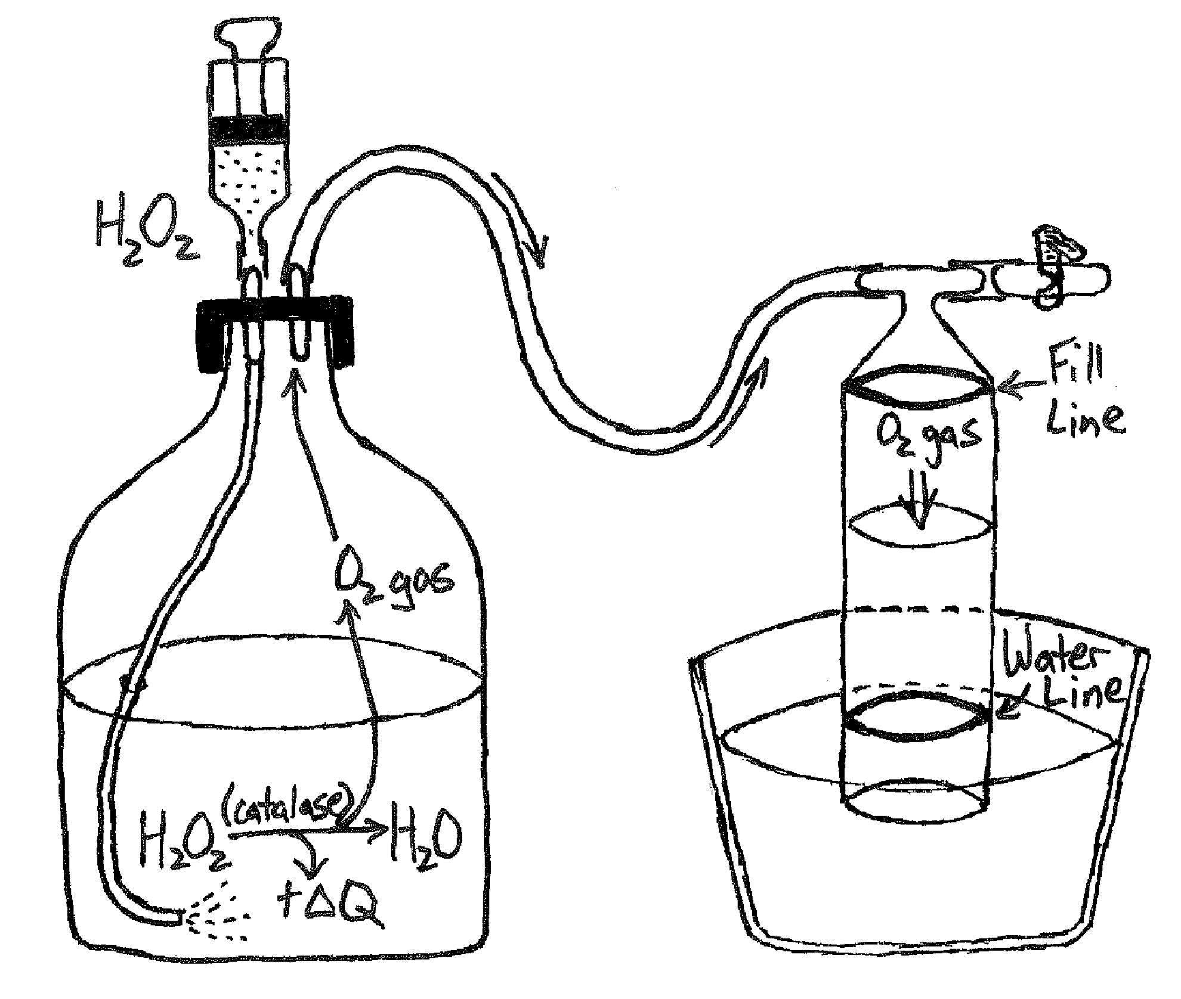

1. Work in groups of 2-3 students.
2. **To set up your reaction bottle**, weigh out 1 g of freeze-dried liver powder and add to a glass bottle with a perforated cap (two holes per cap with airline connectors) and an embedded digital thermometer. Connect a short air-line to the outside of one cap connector and a steel tube to the inside of this connector. Add 200 mL of room temperature physiological saline to the reaction bottle. Cap the bottle, ensuring the thermometer probe and steel tube reach the bottom. Vigorously shake the bottle to mix your liver-powder slurry. Connect a longer air-line to the outside of the second cap connector.
3. **To set up your gas-measurement tube**, first fill your deli cup with tap water up to the drain holes. Use a rubber band to fix the measuring tube upside-down against the deli cup wall. Make sure the blue “water line” matches the water level. The tube should have a T-shaped airline connector in its base (i.e., top of the column). Connect the short side of the T-connector (no valve) to the long air-line from the bottle. Insert the 60 mL syringe into the longer side of the T-connector, which should have a metal valve connected to it. Open the valve (parallel = open).

**C1 Procedure** (each group should repeat twice at each temperature)**:**

1. Use a hot- or cold-water bath to bring it to the first target temperature (25 °C or 10 °C). Swirl the bottle until the slurry approaches the target temperature. **Pull the bottle from the water bath when it’s still ~2°C from the target temperature to avoid overshooting the target.** Keep swirling until the temperature levels off. Open the valve during temperature adjustments to prevent water from being sucked into airlines. **If water gets in an airline: disconnect it, shake the water out, and start over.**
2. Suck up 5 mL hydrogen peroxide into a small syringe and connect it to the bottle’s short air-line. **Don’t squeeze the hydrogen peroxide into the bottle until you’re ready to start!**
3. Use the 60 mL syringe to suck water to the top (red) line of the gas-measurement tube. Try not to suck any water into the airline tubes. When you’re ready, close the valve and detach this syringe. Check that the water level doesn’t start dropping at this point - this might be a sign of an air leak, or that your earlier reaction wasn’t completely finished.
4. Once you’re ready to collect data, record the slurry temperature. Squeeze the hydrogen peroxide into the bottle to start the reaction. Start the stopwatch the moment the hydrogen peroxide hits the liver slurry. Swirl the bottle gently to mix. Watch the water line in the measurement tube, which should move down as gas is produced. Mark the time it takes for the reaction to generate ~40 mL of O2 gas (level of the “water line”). Record the start temperature and seconds-to-completion in your datasheet.

**C1 Data Table:**

|  |  |  |  |  |  |  |  |  |  |  |
| --- | --- | --- | --- | --- | --- | --- | --- | --- | --- | --- |
| Temperature (C) | Time  (s) |  | Temperature (C) | Time  (s) |  | Temperature (C) | Time  (s) |  | Temperature (C) | Time  (s) |
|  |  |  |  |  |  |  |  |  |  |  |

**C1 Analysis:**

Compile all the groups’ data into a single Excel file. Calculate the reaction rate for each test (mL gas per minute). Next, calculate the average, minimum, and maximum reaction rate for each temperature treatment.

**C1 Discussion Questions:**

1. **Did the chemical reaction tend to go faster or slower at warmer temperatures?**

To find out why this happened, ask your instructor about “collision theory”, the theoretical framework chemists use to explain how heat energy drives chemical reactions.

1. **COLLABORATE WITH BIOLOGISTS** – Unlike humans, frogs allow their body temperatures to be the same as the environmental temperature. This means that when it gets cold outside, all of the chemical reactions in the frog’s body occur at the new (lower) temperature. **Based on the results of your experiment, should a frog’s metabolic rate increase, decrease, or stay constant after being placed in a cooler temperature environment?** When you get the chance, explain your prediction to the Biology students.

### Experiment C2 – How much heat is produced by an exothermic chemical reaction?

Like many metabolic chemical reactions, hydrogen peroxide decomposition is an **exothermic** chemical reaction, which means that it releases heat energy. In this experiment, you will use a “reaction bottle” filled with catalase enzyme (liver powder) and physiological saline as a proxy for the human body, and 3% hydrogen peroxide (H2O2) as a source of chemical energy. To better simulate the human body, your bottle will be insulated from cold temperatures using a neoprene insulating sleeve.

**C2 Relevant equations & parameters:**

Decomposition of hydrogen peroxide:

Heat capacity formula (change in internal energy for a given change in temperature):

( heat energy [J]; mass of liquid [g]; specific heat capacity of liquid [J/(g × °C)]; change in temperature [°C])

|  |  |  |
| --- | --- | --- |
| **Parameter** | **Value** | **Units** |
| Molecular weight of H2O2 | 34.01 | g/mole |
| H2O2 density in 3% hydrogen peroxide solution (1% = 1 g per 100 mL) | 0.03 | g/mL |
| Heat energy produced per mole of H2O2 decomposed | 95 | kJ/mole |
| Volume of 3% H2O2 added to reaction bottle | 5 | mL |
| Specific heat capacity of water, *cwater* | 4.18 | J/(g × °C) |
| Mass of water in reaction bottle, *m* (assuming ~200 mL) | 200 | g |

**Make some predictions!**

1. Decomposing one mole of H2O2 into H2O and O2 releases 98.0 kJ of heat energy (1 mole = 6.02×1023 particles). **Use the equation below to calculate the theoretical amount of heat energy (in joules) that should be released by reacting 5 mL of 3% hydrogen peroxide.**

Answer: 419 J

1. **Based on your answer to #1, how much should the bottle temperature increase during this chemical reaction?** There were ~200 g of a water-based solution in the bottle, and the specific heat of water is 4.18 J/(g·°C). This means we expect to need 4.18 J of chemical energy to increase 1 g of water by 1°C.

Answer: 419 J / 4.18 / 200 = 0.50°C

**C2 Procedure:**

1. Insert the reaction bottle into a neoprene sleeve, to reduce the loss of heat energy to the surrounding air. Check that the temperature of your liver slurry is stable, and warmer than 15 **°**C. Suck up 5 mL hydrogen peroxide into a small syringe and connect this syringe to the short air-line.
2. Record the start temperature of your liver slurry (“0 seconds” datapoint). Squeeze the hydrogen peroxide into the bottle and start timing! Record the slurry temperature every 10 s for 2 full minutes (120 seconds).

**C2 Data Table:**

|  |  |  |  |  |  |  |  |  |  |  |  |  |  |
| --- | --- | --- | --- | --- | --- | --- | --- | --- | --- | --- | --- | --- | --- |
| **Time (s)** | **0** | **10** | **20** | **30** | **40** | **50** | **60** | **70** | **80** | **90** | **100** | **110** | **120** |
| **Temperature (°C)** |  |  |  |  |  |  |  |  |  |  |  |  |  |

**C2 Analysis:**

* **How much did the slurry temperature change during the chemical reaction?** **Was it similar to the observed change in temperature from your experiment to the theoretical value you predicted?** (If your measurement is within 0.1°C of the theoretical value, that’s really impressive!)
* Based on the observed change in substrate temperature, scientists can estimate the amount of energy produced by an exothermic reaction. **Use the standard equation for *ΔQ* of water (below) to estimate the amount of heat energy produced by the chemical reaction in your experiment.**

**C2 Discussion Questions:**

Our bodies can convert chemical energy from food into heat energy for thermoregulation or mechanical energy to run and jump. Food contains LOTS of chemical energy. For example, a single Oreo cookie contains 55 “food calories”, which equals 222 kJ of energy (= 222,000 J). **Use the equation below to calculate how many Oreo cookies would a 55 kg (121 lb) student need to eat, to raise their body temperature by 1 °C.** Share your conclusion with the Biology & Physics students. Answer: 1 Oreo! (1.03)

1. **COLLABORATE WITH BIOLOGISTS**: In their Experiment B2, the Biology students measured how much heat volunteers lost from their hands when placed in cold water. **Collaborate with Biology students to calculate the number of Oreo cookies each test subject would need to eat, to replace the heat energy they lost to the cold water.**
2. **COLLABORATE WITH PHYSICISTS & BIOLOGISTS**: In their Experiment P2, Physics students measured the mechanical equivalence of heat energy. **Ask the Physics students for help calculating the number of times a student volunteer could jump a half-meter into the air using the energy from a single Oreo cookie, if they weigh 55 kg (121 lbs).**

Answer: Energy per jump = 55 kg × 0.5 m × 9.8 m/s2 = 269.5 J

#jumps = 222,000 J/269.5 J = 824 jumps

**III. Physics lab activity – chemical & mechanical energy equivalents of body heat**

Like humans, most mammals maintain a constant body temperature, no matter how cold the environment gets. This is called “thermal homeostasis”. **To understand thermal homeostasis, we must master the basic principles of thermodynamics, i.e., the physics of heat energy.**

**Experiment P1 – How much energy does it take to heat water?**

Just like different substances have different abilities to conduct heat, different substances have different abilities to store heat energy. This is called their “specific heat capacity”. In particular, biologists care about water’s specific heat capacity, because our bodies are about 60% water.

In our first experiment, we will compare the amount of energy it takes to heat a container of water, compared to the same mass of copper BB’s. We will take advantage of the fact that heat energy is equivalent to mechanical energy. In fact, “heat energy” is really a form of kinetic energy (i.e., energy of movement). A substance is “hot” when its molecules move (or vibrate) very fast, and it is “cold” when its molecules move very slowly. This means that we can add heat energy to bottle of BB’s or water, simply by shaking it up!

**Relevant equations & parameters:**

Heat capacity formula (change in internal energy for a given change in temperature):

( heat energy [J]; mass of substance [g]; specific heat capacity [J/(g × °C)]; change in temperature [°C])

|  |  |  |
| --- | --- | --- |
| **Parameter** | **Value** | **Units** |
| Specific heat capacity of water, *cwater* | 4.18 | J/(g × °C) |
| Specific heat capacity of copper, *ccopper* | 0.39 | J/(g × °C) |
| Mass of water or BB’s in bottle, *m* | 300 | g |

**P1 Procedure** (repeat with at least 2 volunteers)**:**

1. Measure 300 grams of copper BB’s into a plastic container. Insert a temperature probe at least 1 cm into the center of the BB’s and wait for the reading to stabilize. Record the temperature.
2. Pick a volunteer to shake up the BB’s. Hold the container between your thumb and fingertips, to reduce heat transfer from your hands to the container. Vigorously shake the BB container for a full minute, and take a second temperature measurement at the end of the test. Record the change in temperature in °C.
3. Measure out 300 grams (= 300 mL) of water into a metal thermos and measure the water temperature.
4. Have the same volunteer shake the water vigorously for one minute. Do your best to match the level of vigor with which you shook the BB’s. Record the change in water temperature after the test.

**P1 Data Table:**

|  |  |  |  |  |  |
| --- | --- | --- | --- | --- | --- |
| Substance | Start temp (°C) | End temp (°C) | Change in temp (ΔT) | Specific heat capacity of substance (c) | Heat added (ΔQ) |
| Copper BB’s |  |  |  | 0.39 J/(g × °C) |  |
| Water |  |  |  | 4.18 J/(g × °C) |  |

**P1 Analysis:**

* **For each volunteer, calculate how much heat energy was added to each substance (BB’s or water) using the following equation.** Record these numbers in the Data Table (above).

**P1 Discussion Questions:**

1. In theory, the amount of heat energy added to the water should have been similar to the heat added to the BB’s. However, due to the much higher specific heat capacity of water, it should have been 10.7 times harder to change the temperature of water compared to the copper BB’s (*cwater*/*ccopper* = 4.18/0.39 = 10.7). **Were your results consistent with this prediction? (Yes / No / Pretty close!)**
2. **COLLABORATE WITH BIOLOGISTS:** Biology students conducted an experiment where volunteers placed a hand in 1 liter (1 kg, or 1000 g) of cold water for a full minute. As part of this experiment, they measured the average change in water temperature during these tests. When you get the chance, talk to the Biologists about how this equation can be used to determine how much heat energy students lost to the cold water during the cold-exposure tests.

**How to solve it:**

THOUGHT EXPERIMENT #1: Benny is a female arctic hare who lives in northern Greenland. Like other rabbits, Benny maintains an internal body temperature of 39°C (102°F), even in the middle of winter. However, Benny’s body constantly loses heat energy to the surrounding environment. Benny weighs 3 kg (6.6 lb), or 3000 g. Her body is mostly made of water, so we will assume it has a specific heat capacity of about 4.18 J/(g·°C). **How many joules of chemical energy will Benny need to spend, to raise her body temperature by 1°C?** Answer: 3 kg × 4180 J/[kg·°C] × 1°C = 12,540 J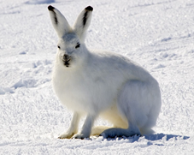

**How to solve it:**

THOUGHT EXPERIMENT #2: Benny must replace lost heat energy using chemical energy from her food. According to the USDA, carrots have an energy density of about 0.5 “food calories” per gram, or about 2100 J/g. **How many grams of carrot would Benny need to eat, to replace the energy she used raising her body temperature in Thought Experiment #1?** Answer: 12,540 / 2100 = 6 g carrots

1. **COLLABORATE WITH CHEMISTS:** Humans and rabbits heat their bodies using chemical energy from food. The chemistry students have been exploring the production of heat energy from a chemical reaction. Human foods can contain a LOT of chemical energy. A single Oreo cookie contains 55 “food calories”, which equals 222 kJ of chemical energy (= 222,000 J). **Ask the Chemists, how many Oreo cookies would a 55 kg (121 lb) student need to eat, to raise their body temperature by 1 °C?**

**Experiment P2 – Mechanical equivalence of heat energy**

To get more context for how energetically expensive it is for a mammal to maintain a constant high body temperature, let’s explore another way Benny might prefer to use her energy – by hopping around! To do this, we need to quantify the mechanical equivalence of heat energy. This requires a more sophisticated experiment than just shaking up a thermos of water.

**Relevant equations & parameters:**

Gravitational potential energy (in joules):

( potential energy [J]; mass of suspended object [kg]; height [m]; rate of acceleration due to gravity [m/s2])

|  |  |  |
| --- | --- | --- |
| **Parameter** | **Value** | **Units** |
| Rate of an object’s acceleration due to Earth’s gravity, *g* | 9.8 | m/s2 |

1. THOUGHT EXPERIMENT #3 The energy it takes for Benny to hop 1 meter high is equal to her body’s gravitational potential energy at the highest point of her jump. **Based on the equation for gravitational potential energy (above), how much chemical energy does Benny need to make a single hop 1 m high?**

How to solve it: 3 kg × 1 m × 9.8 m/s2 = _____ J Answer: 3 kg × 1 m × 9.8 m/s2 = 29.4 J per hop

1. THOUGHT EXPERIMENT #4 – **Based on your calculations, how many 1 m hops could Benny have made with the same energy she used to increase her body temperature by 1°C?**

Answer: 12,540 / 29.4 = 426.5 hops

**Measuring the mechanical equivalence of heat energy – the Joule Apparatus!**

James Joule (1818-1889) is one of history’s most famous experimental physicists, because he obtained the first accurate measurements equating mechanical energy with heat energy. In his experiment, he converted nearly all of a weight’s gravitational potential energy (PEG) into measurable heat energy, by connecting the weight to a paddle inside an insulated container of water. Normally a dropped weight would release all its kinetic energy at once, by crashing into the ground. In Joule’s setup, however, a gear system makes the paddle spin very fast while the heavy weights lower at a constant slow speed, so nearly all of its energy goes into heating the water. 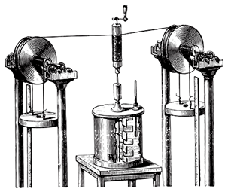

Dr. Raffel created a homemade version of Joule’s apparatus from an old-fashioned ice cream maker. In this version, each 9 kg weight drops ~1 meter at a time and there is 3 kg (3 L) water inside the chamber.

**Make some predictions!**

1. **If we drop a 9 kg weight from a 1 m height, how much gravitational potential energy does it start with?**

How to solve it: 9 kg × 1 m × 9.8 m/s2 = _____ JAnswer: 9 kg × 1 m × 9.8 m/s2 = 88.2 J

1. **How much heat energy should it take to increase the 3 kg of water’s temperature by 1°C?** *(Hint: this is the same calculation as for the energy to increase Benny’s body temperature in Thought Experiment #1)*

Answer: 3 kg × 4180 J/(kg·°C) × 1°C = 12,540 J (same as for Benny above)

1. Assuming no sources of experimental error, **how many times should we need to drop an 9 kg weight from a height of 1 m, to increase the temperature of 3 kg water by 1 °C? How about 0.1 °C?**

Answer: 12,540 J / 88.2 J = 142 ; 213 × 0.1 = 14.2

**Procedure P2:**

1. Measure 4 L of water and slowly add it to the central canister. Cover the hole with masking tape to prevent water from splashing out. Next, insert a high-precision temperature probe (accurate to 0.01 °C) into the small hole to the side of the canister. Wait for the reading to settle down before starting. Station students to monitor the temperature probe and to make sure the lines don’t fall out of the gears.
2. Record the starting temperature. Have two students take turns hooking the 8 kg weight to the line on each end of the apparatus. Let each weight drop to the ground, driving the paddle as it drops. You might sometimes need to give the gears a little push to start them moving, if the gear axle isn’t perfectly aligned.
3. After the first four drops, wait for the temperature reading to equilibrate again and record the new temperature. Repeat until you have completed at least 32 drops.

**P2 Data Table:**

|  |  |  |  |  |  |  |  |  |  |
| --- | --- | --- | --- | --- | --- | --- | --- | --- | --- |
| **Total 1 m drops** | **0** | **4** | **8** | **12** | **16** | **20** | **24** | **28** | **32** |
| **Temperature (°C)** |  |  |  |  |  |  |  |  |  |

**P2 Discussion Questions:**

1. **How well do your results match your predicted number of drops needed to change the water temperature by 0.1 °C?**
2. **COLLABORATE WITH BIOLOGISTS & CHEMISTS** – A single Oreo cookie contains 55 “food calories”, which equals 222 kJ of energy (= 222,000 J). **How many times could a student weighing 55 kg jump a half-meter in the air, using the amount of chemical energy from a single Oreo cookie?** Share your results with the Biology & Chemistry students.

**How to solve it (1st step): 55 kg × 0.5 m × 9.8 m/s2 = _____ J per jump**

Answer: 55 kg × 0.5 m × 9.8 m/s2 = 269.5 J per jump; # Jumps = 222,000 J ÷ 269.5 J = 824 jumps